|  |
| --- |
| NAMI COLLEGE |
| Report on Web Assignment for 1st Year |
| CSY1018 |
|  |
| **Name Suraj Basnet** |
| **UN ID: 16418527** |

Submission Date:

**4/9/2017**

|  |
| --- |
| Github link:https://basnetbasnet.github.io/sbasnetCSY1018/ |

## Contents:

## Introduction....................................................................................................................... 1

## Sketches……………………………………………………………………………………………………1

## Design

## Sketches…………………………………………………………………………………………………1-4

## Sketch of my homepage………………………………………………………………..1

## Sketch of my Bio……………………………………………………………………………2

## Sketch of my CV……………………………………………………………………………..3

## Sketch of Contact……………………………………………………………………………4

## Wireframes………………………………………………………………………………………………5-7

## Wireframe of my homepage………………………………………………………….5

## Wireframe of my Bio……………………………………………………………………….6

## Wireframe of my CV…………………………………………………………………………6

## Wireframe of Contact………………………………………………………………………7

## Final Design……………………………………………………………………………………8-19

## Final design of my homepage……………………………………………………………8

## Final design of my Bio……………………………………………………………………….8

## Final design of my CV………………………………………………………………………..9

## Final design of Contact………………………………………………………………………9

## Validation………………………………………………………………………………………………10-11

## Good Practice…………………………………………………………………………………………11-14

## Social Icon……………………………………………………………………………………….11

## Responsive……………………………………………………………………………………12,13

## Google fonts…………………………………………………………………………………….14

Conclusion & Referencing……………………………………………………………………………..14

## Sketches:

Sketches are very important to design your website.

Firstly I designed my sketches in order to build my website. I had sketched 4 pages i.e. Home page, Bio page, CV page and Contact page.

All the sketches are shown below:

## Sketch of Home page:

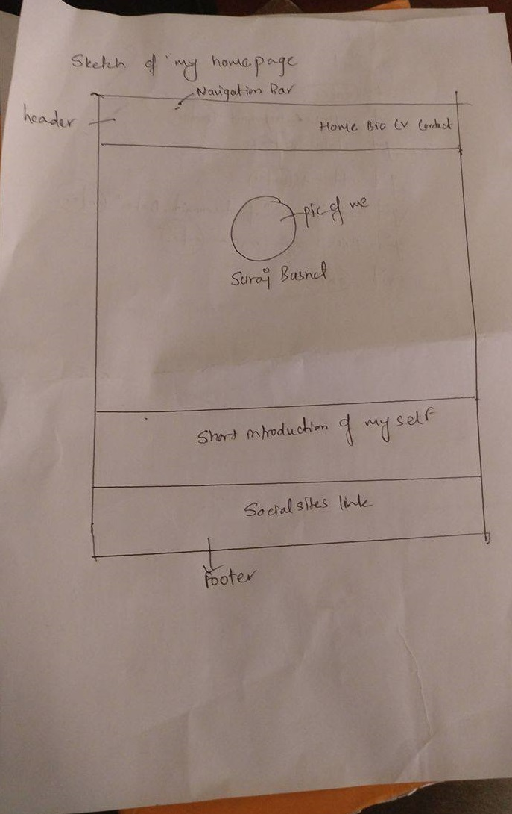

# Sketch of my Bio page:

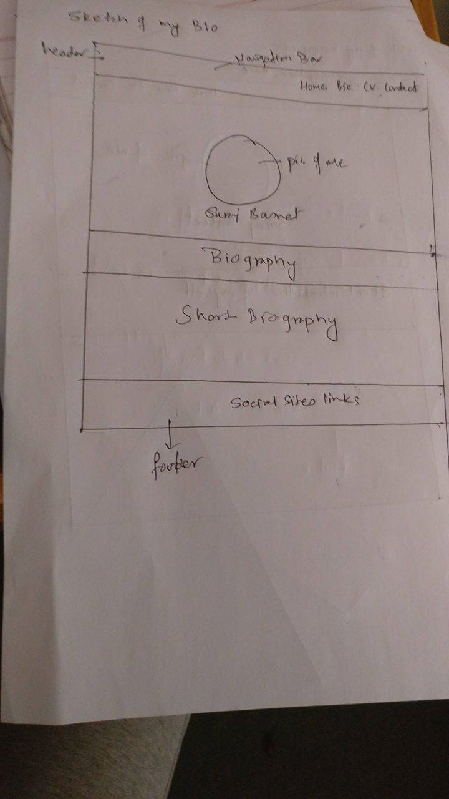

## Sketch of my CV:

**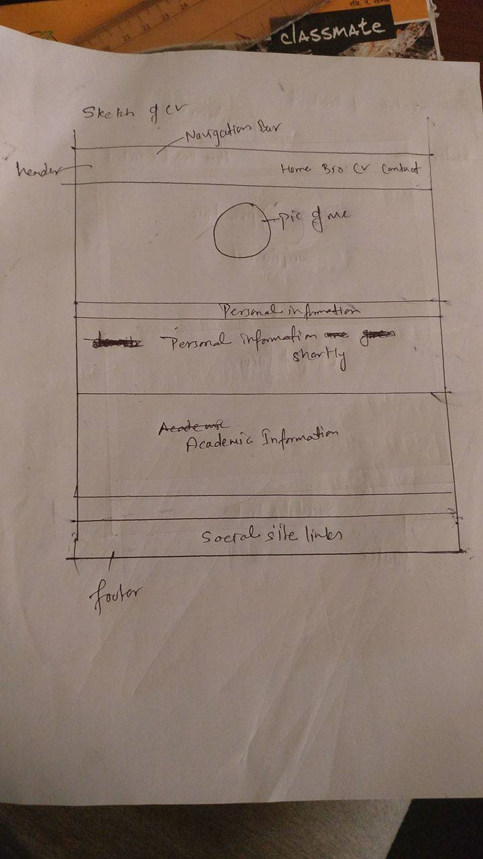**

## Sketch of my Contact:

### C:\Users\User\AppData\Local\Microsoft\Windows\INetCache\Content.Word\17797531_1373772762662099_1347490229_o.jpg

### Wireframes

After I build up my sketch I build my Wireframes. It is the second phase of web development.

It will make easier to build up the website. So, in order to make my website good I designed my wireframes which contains home page, bio page, cv page and contact page.

## Wireframe of homepage:

Footer Part

Navigation Part

## Wireframe of Bio:

Footer Part

Biography Content

Navigation Part

## Wireframe of CV

Footer Part

Short Personal Information

Navigation Part

## Wireframe of contact

Footer Part

form

Navigation Part

## Final Design:

## My home page:

My home page is very simple. It contains header body and footer section. In header section I have included Home Bio CV and Contact. In my body section I have pictures of myself where I have used hover and it rotates when the mouse cursor goes to its area and if clicked it is linked to homepage. Similarly, in footer section I have Facebook and Instagram logo which links to my profile.

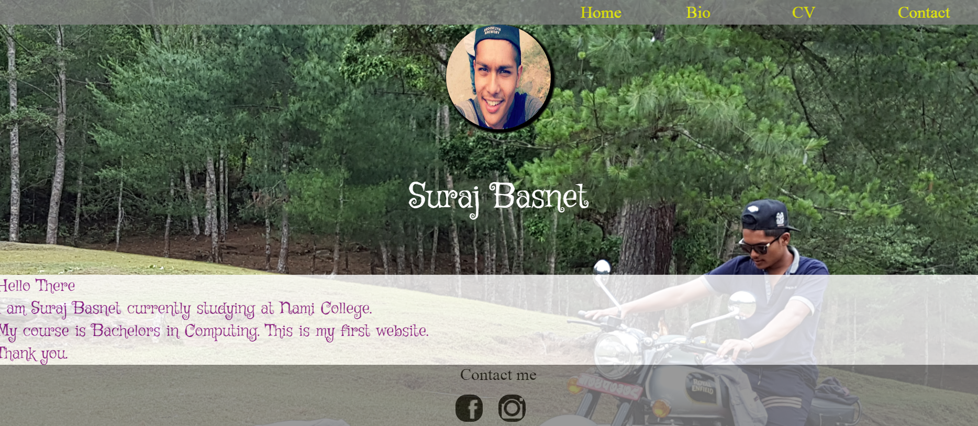

## My bio page:

It is almost same as my home page. Header and footer sections are all same. Only the different is in the middle section of my bio page I have given my Biography.

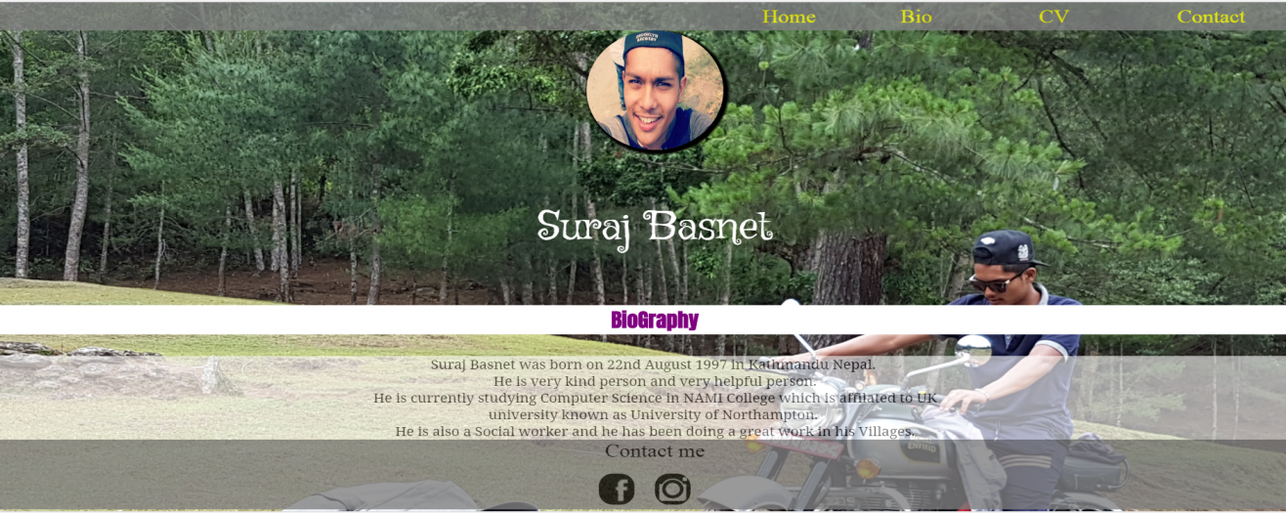

## My CV page:

My CV page is also same as my home page where I have included header and footer. In the body section, I have my personal information and my academic qualification.

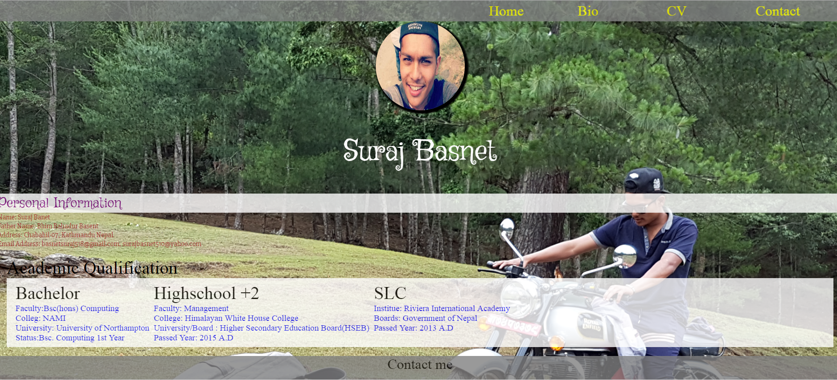

## My Contact page:

My contact page is all same as other pages. Header and footer are same as home page and other pages. But in the body section I have made a form for the user to contact me.

All the information should be given in order to contact. Otherwise the information won’t be submitted.

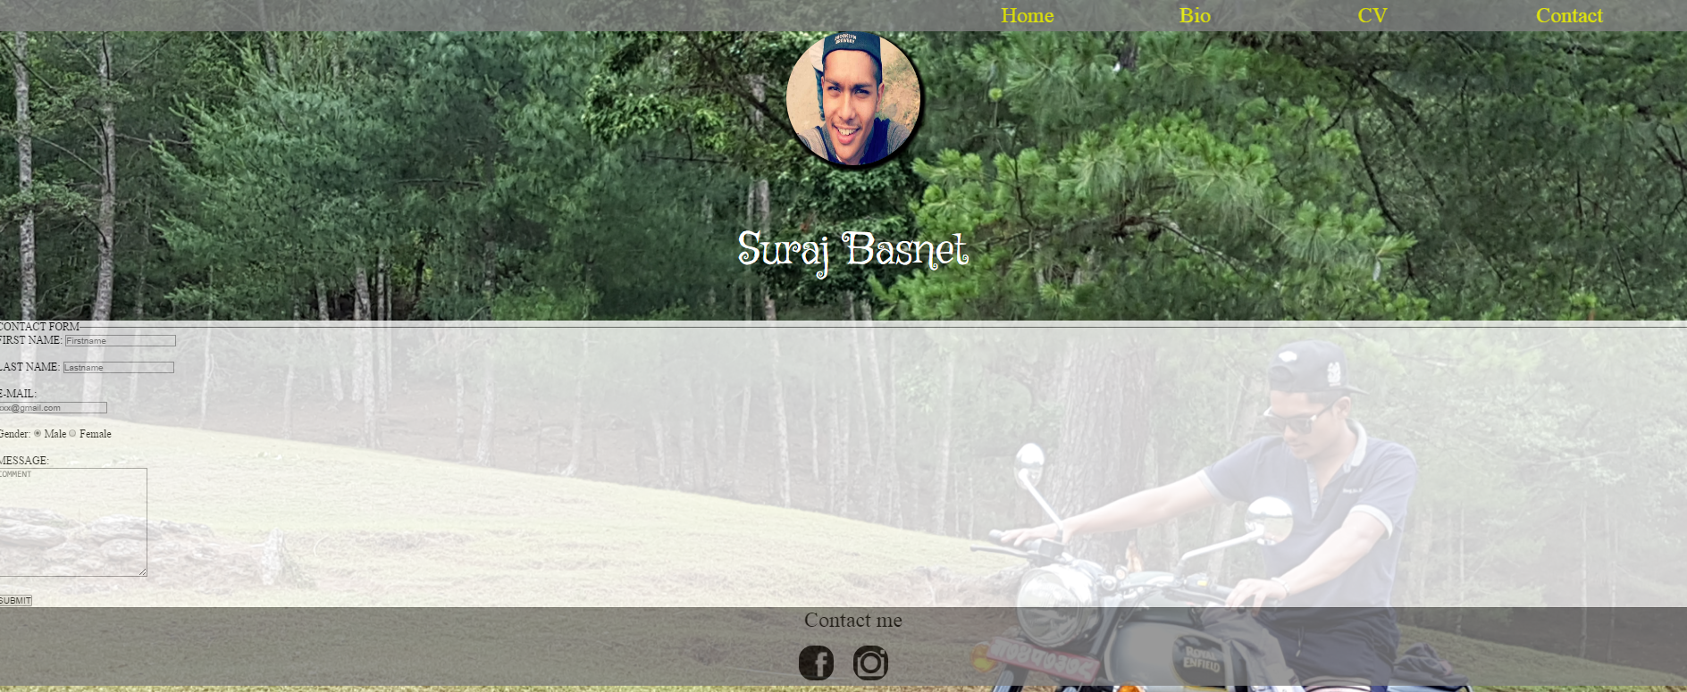

## Validation:

I have used <https://validator.w3.org/> for validating my html documents and <https://jigsaw.w3.org/css-validator/> for validating my css documents.

It is very good practice to use Validator for your webpages. It helps to find out the problem in the codes and it will be easier to sort out the problems. The images of Validation are shown below:-

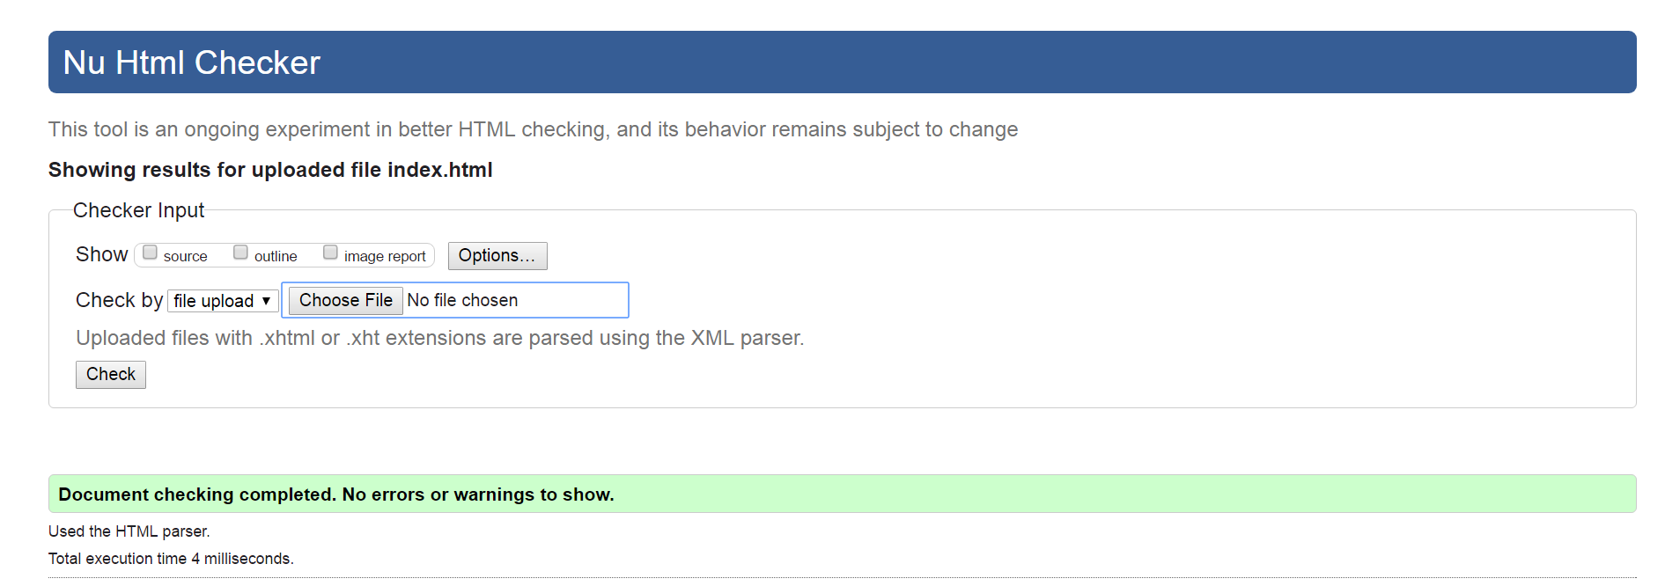

Validation of Index.html

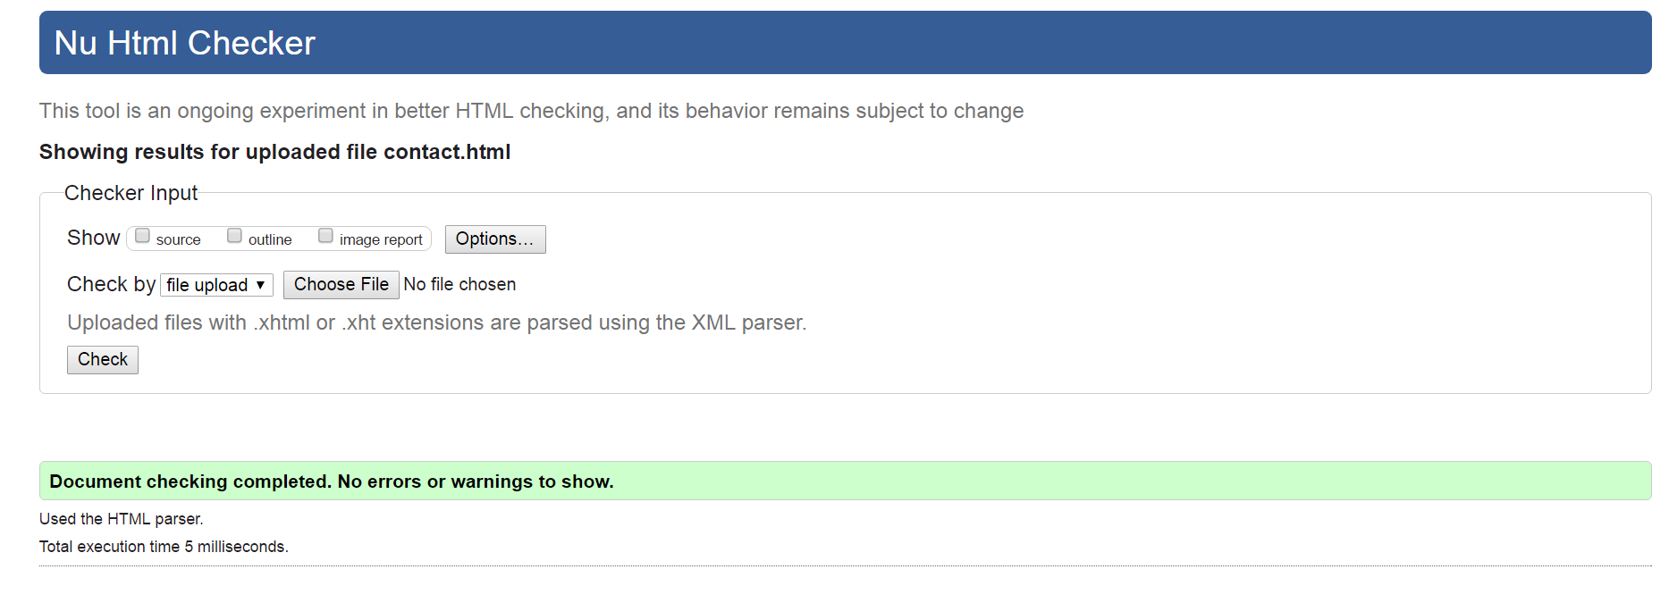

Validation of Contact.html

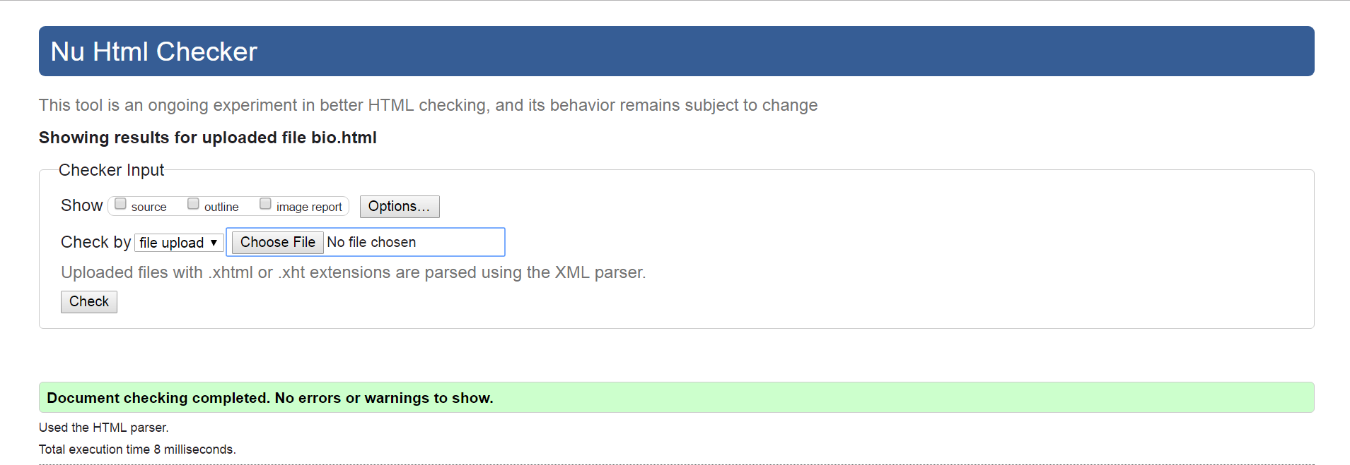

Validation of bio.html

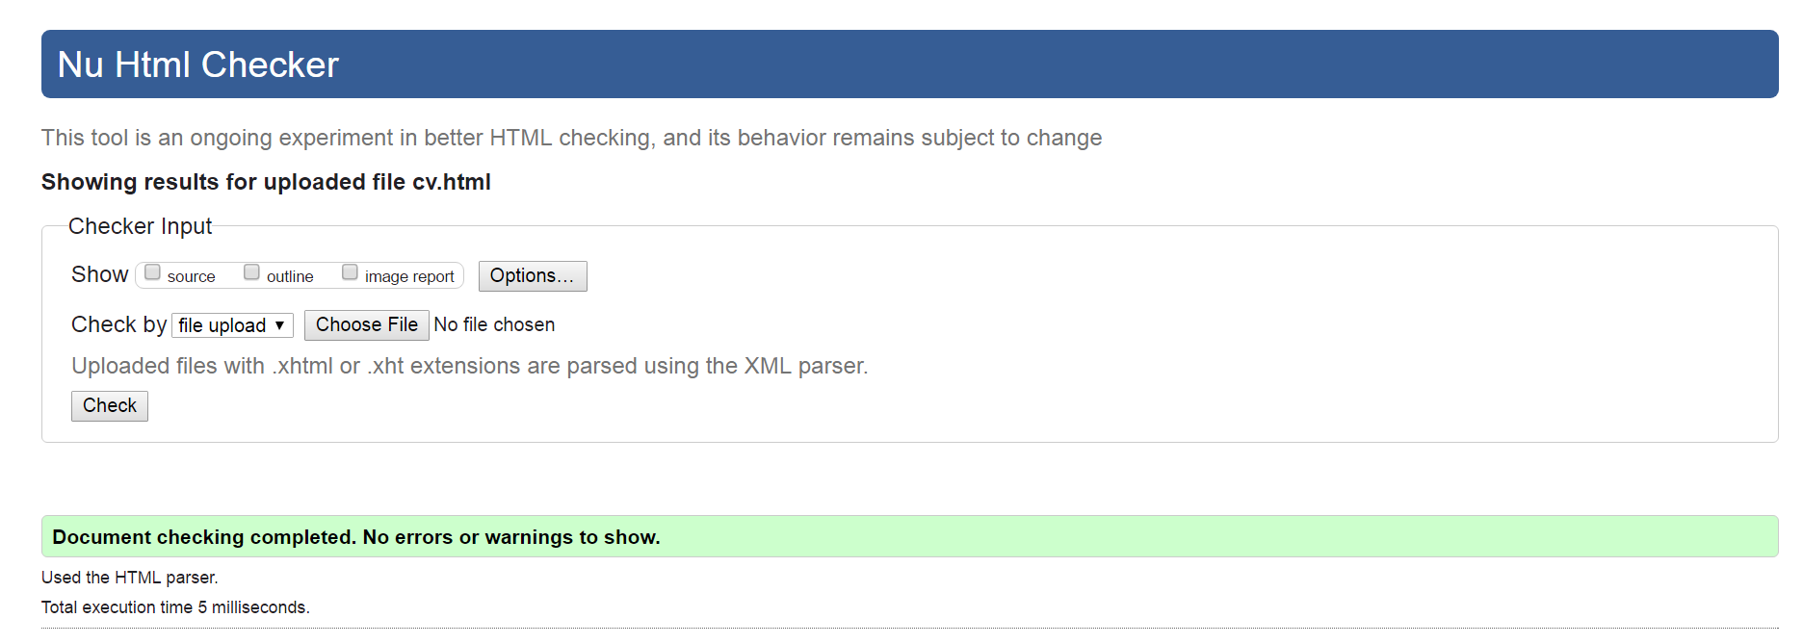

Validation of CV

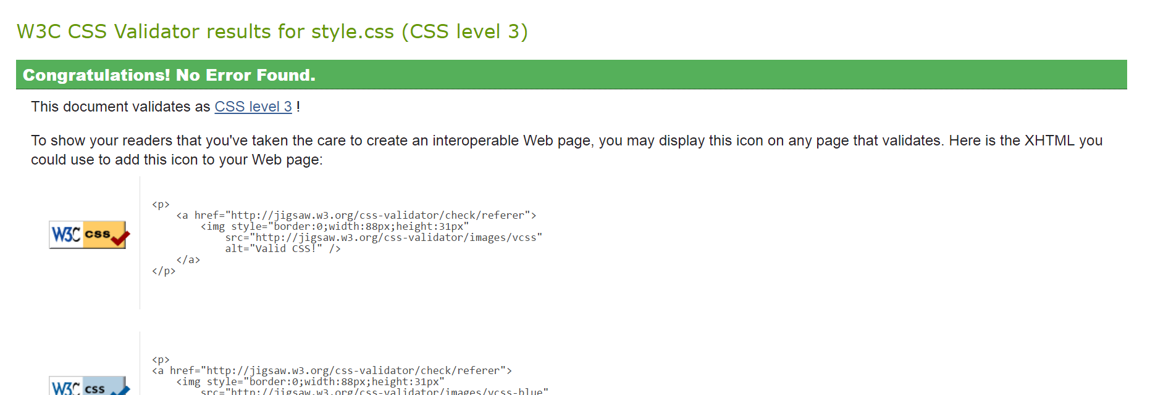

Validation of style.css

## Good practice:

In order to make my webpage look good I have linked my webpage to Social sites and made my website responsive and also used Google fonts to make my webpage attractive to user.

## Social icon:

In the footer section, I kept icon of Facebook and Instagram where it will directly links to my profile. So, that user can contact to me directly through this website.



### Responsive:

In today’s generation people are mostly familiar with mobile phones. So, I have made my website responsive so that people can view my website through their mobile devices as well.

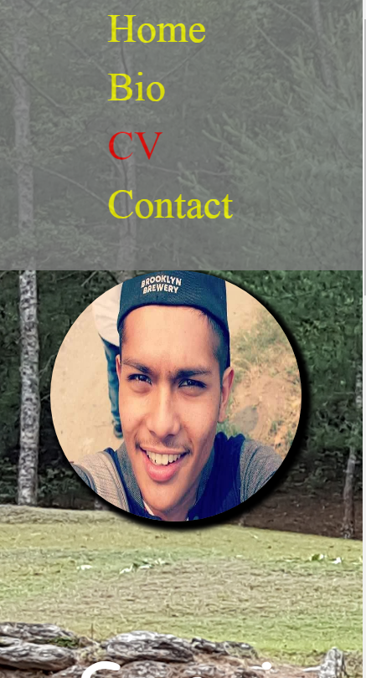

**Home page**

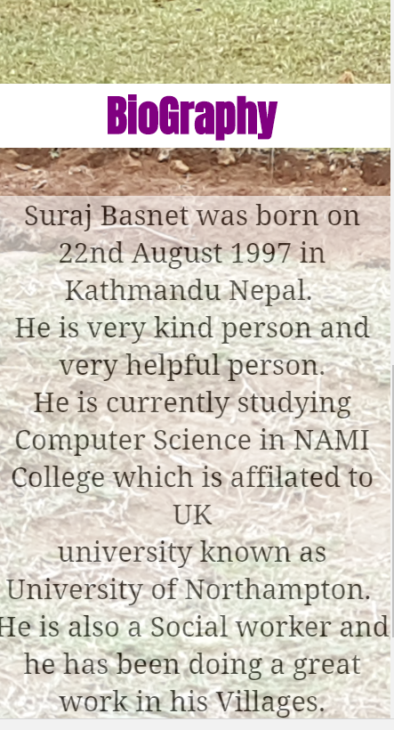

**Bio Page**

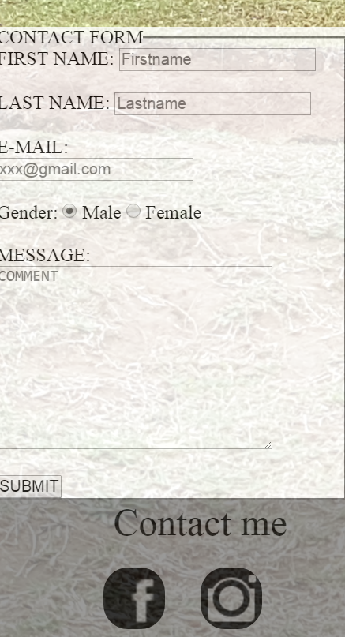

**Contact page**

### Google font:

In order to look my website attractive I used Google fonts. I had linked the Google fonts to my css. Some of the Fonts that I have used are listed below.

## C:\Users\User\Desktop\google font.PNG

## C:\Users\User\Desktop\googlefont1.PNG

## Conclusion:

I was able to complete my webpages in 4 weeks. I developed my webpages very slowly. I studied, researched about the codes and develop the website. As this is my assignment I had given certain time to complete my webpages. This is my first time developing website. I learned many things and I am very much happy doing this work. As it was my first time I took help from my seniors, teachers and my friends in order develop this webpages but now I can surely say that I can develop webpages on my own and also can make it good using various codes.

## Referencing:

Markup Validation Service. 1994. *CSS tutorial*. [ONLINE] Available at: <https://www.w3schools.com/>. [Accessed 31 March 2017]